Module 1: Risk and Insurance 1
Lesson 3: Life Insurance Policies as Contracts 1
Learning Objectives 1
Insurance Contracts 1
Learning Objective 1
What do you think? 1
Insurance Contracts 1
What do you think? 2
Types of Contracts 2
Learning Objective 2
Unilateral and Bilateral Contracts 3
Like-for-Like Exchange 3
Aleatory and Commutative Contracts 3
Aleatory Contract 3
What do you think? 4
Bargaining Contracts 4
Contracts of Adhesion 4
Policy Language in Contracts of Adhesion 5
Informal and Formal Contracts 5
What do you think? 5
Valid, Void, and Voidable Contracts 6
Let’s review 7
A Valid Contract 7
Learning Objective 7
Valid Contract Requirements 8
Mutual Assent 8
Legally Adequate Consideration 8
Lawful Purpose 9
Insurable Interest 9
What do you think? 11
Insurable Interest Relationships 12
Insurable Interest - Step Relative 12
What do you think 12
Divorce 13
Let’s review 13
Contractual Capacity 14
Contractual Capacity for Insurance Companies 14
Contractual Capacity for Individuals 15
Minors 15
Mental Capacity 15
Let’s review 16

Module 1: Risk and Insurance

Lesson 3: Life Insurance Policies as Contracts

Learning Objectives
After studying this lesson, you will be able to:
- Define a contract and identify the parties to an insurance contract.
- Differentiate among types of contracts.
- Differentiate between valid (hợp đồng hợp lệ), void (hợp đồng vô hiệu), and voidable (hợp đồng có thể bị vô hiệu) contracts.
- Identify the general requirements to create a valid contract.

Insurance Contracts

Learning Objective
Define a contract and identify the parties to an insurance contract.

What do you think?
Do you think Simone and Able Life negotiated the terms of the policy when she applied? Do you think that she can negotiate the terms now that the company has delivered the policy?
- She could negotiate the contract terms at the time of application.
- She can negotiate the terms at the time of delivery.

- Neither
- Both
Answer: Neither
Explanation: As Simone is learning, insurance policies are contracts, but they’re different from most contracts you’re used to. One example is the ability of only one party to set the terms of the agreement. You’ll learn more about this and other characteristics of insurance contracts in this lesson.

Insurance Contracts
An insurance policy is a legally enforceable contract (có hiệu lực pháp lý) between a policyowner who applies for and owns the policy—Simone, in our example—and the insurer that issues the policy—Able Life Insurance Company.

By accepting this insurance contract, Simone agrees to pay a premium for the coverage (để được bảo vệ). Able Life promises to provide the coverage (quyền lợi bảo hiểm) as long as Simone keeps paying her renewal premiums (khoản phí bảo hiểm gia hạn định kỳ).

What do you think?
- What’s the worst thing that will happen if Simone doesn’t keep her agreement to pay the premiums on her life insurance policy?
- Able Life can sue her in a court of law for recovery of the missed premium payments
- Simone’s insurance coverage will cease

Answer: Simone’s insurance coverage (quyền lợi bảo hiểm) will cease (chấm dứt)
Explanation: Simone is not legally obligated to pay premiums so she can’t be sued. However, if she does not pay her premiums, her policy will lapse (The termination of an insurance policy for nonpayment of premium.)

- Can Able Life choose to cancel Simone’s life insurance policy?
- Yes
- No
Answer: Yes
Explanation: For a life insurance policy, the insurer is legally obligated (nghĩa vụ pháp lý) to provide coverage according to the policy’s terms, as long as the policyowner pays the premiums. It can’t just decide to discontinue the coverage.

Types of Contracts

Learning Objective

Differentiate among types of contracts

Contracts come in a variety of types. Every state has a large body of law (hệ thống pháp luật đồ sộ) that governs the operation and effect of contracts (điều chỉnh cách thức hoạt động và hiệu lực của hợp đồng).
The specific rules of contract law that apply to a given contract vary by the type of contract.
Let’s look at some of the most common types.

Unilateral and Bilateral Contracts

(Hợp đồng đơn phương và hợp đồng song phương)
Able Life can’t make Simone pay her premiums. But as long as she does pay, Able Life’s promise to pay the policy’s benefit is legally enforceable (có hiệu lực pháp lý).
Because only one party to the contract makes a promise that can be enforced in a court of law (được thực thi trước pháp luật), the insurance contract is a unilateral contract (hợp đồng đơn phương).
In a bilateral contract (hợp đồng song phương), both parties make legally enforceable promises (cả hai bên đều đưa ra những cam kết có hiệu lực pháp lý).

Like-for-Like Exchange
A transaction where both parties trade items or services of equal value and similar nature.

Aleatory and Commutative Contracts

In a commutative contract (hợp đồng đối ứng), the parties agree to exchange specified items or services that are equal in value.
In an aleatory contract, one party exchanges something of value for the other party’s conditional promise.

Aleatory Contract
Under an aleatory contract (hợp đồng ngẫu hiên), if the specified event occurs, one party may then receive something of greater value than that party gave.
If a policy lapses soon after purchase ...
The policyowner gets little or nothing while the insurer keeps premiums paid.
Under an aleatory contract, if the specified event occurs, one party may then receive something of greater value than that party gave.
If the insured dies soon after purchase ...
The insurer receives few premiums while the beneficiary receives the full death benefit.

What do you think?
Is a life insurance contract a commutative or aleatory contract?
- Commutative
- Aleatory
- Could be either one
Explanation: A life insurance policy is an aleatory contract. The policyowner exchanges something of value (the premium) for the insurer’s conditional promise to pay benefits if the insured dies while the policy is in force.

Bargaining Contracts
In a bargaining contract, both parties set the terms and conditions.

Contracts of Adhesion
Unlike a bargaining contract, a contract of adhesion (hợp đồng gia nhập) is one in which one party sets the contract terms that the other party must accept or reject outright.
An insurance contract is not a bargaining contract because the policyowner has no say about the terms of the contract. Able Life prepares the contract and Simone must accept it or reject it without any bargaining between them. This makes it a contract of adhesion.
With a contract of adhesion, the courts usually interpret any ambiguities (tòa án thường giải thích bất kỳ sự mơ hồ nào) in the contract against the party that drafted the contract.
For example, if a provision (điều khoản) in Simone’s life insurance policy is ambiguous, a court would likely interpret the ambiguous policy provision against Able Life and in favor of Simone, or her beneficiary.

Policy Language in Contracts of Adhesion
Life insurance contracts have easily readable language and problems that can crop up by having easily readable language.

Informal and Formal Contracts
Informal contract: A contract that is enforceable because the parties to the contract met requirements concerning (đáp ứng) the substance (nội dung) of the agreement rather than requirements concerning the form of the agreement (hình thức của thỏa thuận)
Formal contract: A contract that is enforceable because the parties met certain formalities concerning the form of the agreement.
A formal contract requires the parties to meet certain formalities, such as creating the contract using legal counsel or having the contract validated by a notary public. A real estate sales contract is a formal contract.

What do you think?
- Is an insurance contract an informal contract?
- Yes
- No
Answer: Yes
Explanation: Most contracts today, including insurance contracts, are informal contracts. They depend on substance rather than form and can exist without the aid or validation of a lawyer. Even though informal contracts can be oral or written, insurers always provide the policyowner with a written insurance policy. It’s a good business practice, and some states require it.

- Select the characteristics of an insurance contract. (Choose all that apply.)
- Commutative contract
- Aleatory contract
- Bargaining contract
- Contract of adhesion
- Informal contract
- Formal contract
- Unilateral contract
- Bilateral contract
Answer: Aleatory contract, Contract of adhesion, Informal contract, Unilateral contract
Explanation:
- Commutative contract: The parties to the contract exchange items or services that are relatively equal in value.
- Aleatory contract: One party provides something of value to another in exchange for a conditional promise.
- Bargaining contract: Both parties, as equals, set the terms and conditions of the contract.
- Contract of adhesion: One party prepares the contract for the other party to accept or reject as a whole, without any bargaining.
- Informal contract: Enforceable because the parties to the contract met the requirements concerning the substance of the agreement.
- Formal contract: Enforceable because the parties to the contract met requirements concerning the form of the contract itself
- Unilateral contract: Only one party’s promise is legally enforceable.
- Bilateral contract: Both parties make legally enforceable promises.

Valid, Void, and Voidable Contracts
Whether Simone’s rights under her life insurance policy and Able Life’s obligations under the policy are enforceable at law depend on whether the contract was issued according to certain principles of contract law and is a valid contract.
A contract is valid if it satisfies all legal requirements. A contract that does not meet one or more of the legal requirements to create a valid contract is void. A voidable contract is a contract under which one party has the right to avoid his obligations under the contract. The other party, however, is bound by the terms of the contract.

valid contract: A contract that is enforceable at law because it satisfies all legal requirements.
Void: Something that was never valid. A void contract is one that was never enforceable at law.
voidable contract: A contract in which a party has the right to avoid obligations under the contract without incurring legal liability.

Let’s review
Decide whether the sentences below describe a valid, void, or voidable contract.

- A contract in which a party has the right to reject her obligations under the contract.
- Valid
- Void
- Voidable
Answer: Voidable
- A contract that satisfies all the legal requirements and is enforceable by law.
- Valid
- Void
- Voidable
Answer: Valid
- A contract that does not meet one or more of the legal requirements to create a legally enforceable contract.
- Valid
- Void
- Voidable
Answer: Void

A Valid Contract

Learning Objective
Identify the general requirements to create a valid contract.

Valid Contract Requirements
According to the laws in most of the United States and many other countries, contracts are valid and enforceable at law only if they meet certain requirements. Click or touch the arrows below to learn about these requirements.

Mutual Assent
(Sự thỏa thuận lẫn nhau)
The parties must reach a “meeting of the minds” (thỏa thuận về ý chí) about the terms of the contract, which means that both, or all, of the parties to the contract have an understanding of the terms and agree to those terms.
The parties reach a meeting of the minds about the terms of a contract when
One party makes an offer and the other party accepts that offer
All parties express intent to be bound by the terms of the contract

Legally Adequate Consideration
(Giá trị trao đổi hợp pháp)
The parties to the contract must exchange consideration (trao đổi giá trị), which means that each party must give or promise something that is of value to the other party.
The rules of contract law don’t require the parties to exchange equal consideration. Whatever is of value to the parties generally is considered to be legally adequate consideration.

Applicant's Consideration
If the applicant had not paid the initial premium, she would not have provided consideration (giá trị trao đổi) and no contract would exist.
Renewal premiums (phí bảo hiểm tái tục) payable to keep the policy in force are not consideration for the formation of the contract but a condition necessary for the continuation of the contract.
The applicant’s consideration is completing the insurance application and paying the initial premium while the insurer’s consideration is a promise to pay policy benefits if the conditions stated in the policy occur.

Lawful Purpose

A contract will NOT be valid if it was
- Made for a purpose that is illegal
- Against the public interest (đi ngược lại lợi ích cộng đồng)
An agreement between two parties to commit a criminal act (hành vi phạm tội), such as an agreement to kill an individual in exchange for money, is not legally enforceable. A contract can’t require a party to the contract to break the law.
Recall that life insurance policies might be considered unlawful wagering agreements (thỏa thuận đánh cược trái pháp luật) if not for the insurable interest(lợi ích được bảo hiểm) requirement.

Insurable Interest
Insurable interest (quyền lợi bảo hiểm) (mối quan hệ hợp pháp giữa người mua bảo hiểm hoặc gười thụ hường với người được bảo hiểm) is the interest that an insurance policyowner or beneficiary has in the risk that is insured. A policyowner or beneficiary has an insurable interest if he is likely to suffer a genuine loss (tổn thất thực sử) or detriment (thiệt hại)if the event insured against occurs.
Laws in most jurisdictions (khu vực pháp lý) require insurable interest to be present at policy issue to prevent people from buying insurance as a wager, hoping to profit when they have no risk of financial loss.
People generally have more to gain by living than by dying, so insurers presume (mặc định rằng) people to have an insurable interest in their own lives.
However...

A policyowner who purchases insurance on someone else's life must have an insurable interest in the insured’s life when the policy is issued ...
Insurable Interest - Beneficiary

And...

Most insurance companies require the beneficiary to have an insurable interest in the insured’s life when the policy is issued.

What do you think?
Laws in many jurisdictions require the applicant for a third-party life insurance policy to have an insurable interest in the proposed insured's life. An insurable interest is presumed to exist between certain family members.
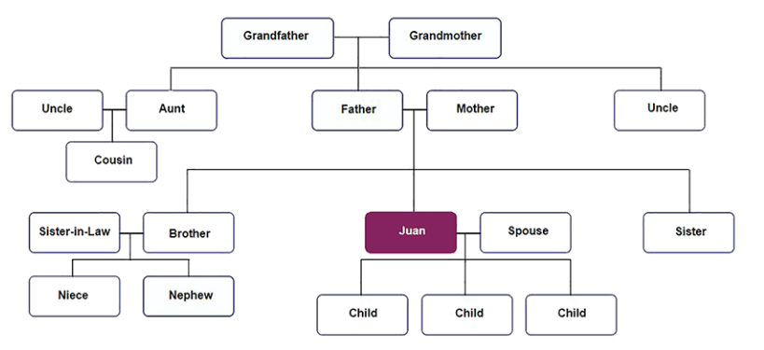

Juan and his family are listed on the family tree. Choose each of Juan's relatives who would likely satisfy automatically an insurable interest requirement and be able to obtain an insurance policy on his life.
- Juan's parents
- Juan's spouse
- Juan's children
- Juan's uncles and aunts
- Juan's cousin
- Juan's brother and sister
- Juan's sister-in-law
- Juan's nieces and nephews
- Juan's grandparents

Answer: Juan's parents, Juan's spouse, Juan's children, Juan's brother and sister, Juan's grandparents

Explanation: Spouses, children, parents, siblings, grandparents, and grandchildren automatically satisfy the requirement. Other relatives do not.

Insurable Interest Relationships
The bonds of affection (mối quan hệ tình cảm) and financial dependence between certain family members are assumed by law to create an insurable interest between an insured and a policyowner or beneficiary.
Insurable interest is assumed for the insured’s spouse, child, parent, grandparent, grandchild, and sibling,
No insurable interest is assumed for insured’s aunt, uncle, cousin, niece, nephew, and more distant relatives.
Let’s look again at a family tree to see who has an insurable interest based only on family relationship.
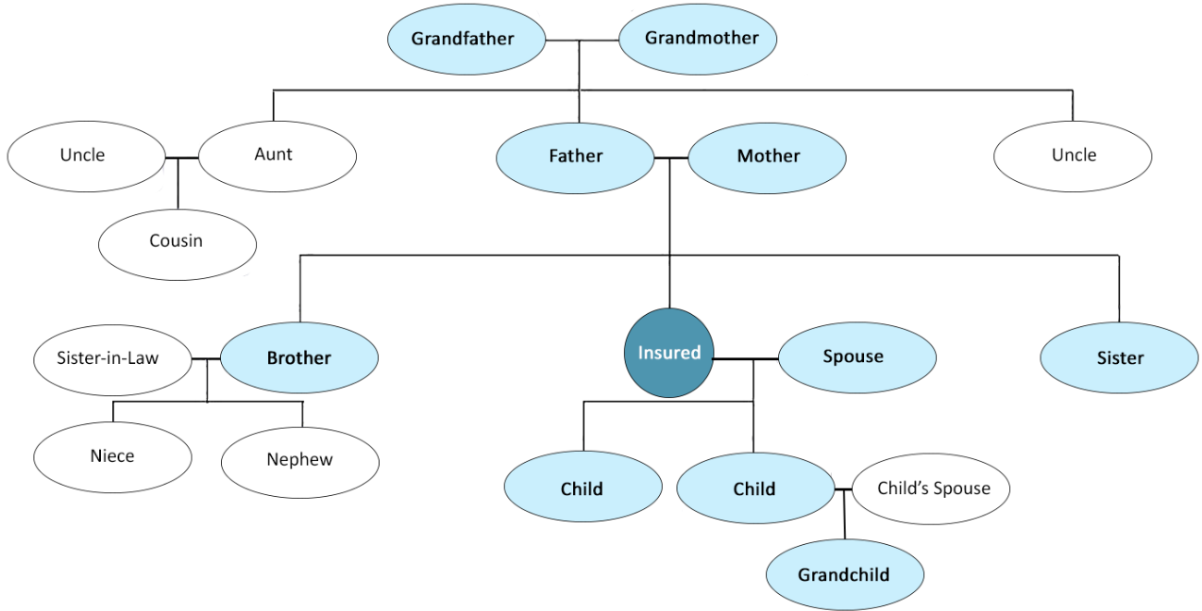

Insurable Interest - Step Relative
When a policyowner or beneficiary is a step relative (stepfather, stepdaughter, etc.), distant relative, business partner, or friend, the bonds of affection and financial dependence may not be so clear.
The insurer investigates these relationships on a case-by-case basis to determine insurable interest. If it exists, the insurer can issue the policy.

What do you think
- Suppose Simone’s business partner, Kathleen, applied for insurance coverage on Simone’s life, and named herself as the beneficiary. Do you think an insurable interest is present here?
- Yes
- No
- Can’t tell. Need more information
Answer: Yes
Explanation: Because of their business relationship, Kathleen has a financial interest in Simone’s continued contribution to their business. Most likely, this business relationship satisfies the insurable interest requirement.

- Suppose the delivery man applied for coverage on Simone’s life. Is an insurable interest present here?
- Yes
- No
- Can’t tell. Need more information
Answer: Yes
Explanation: The insurer would probably decide that Simone’s delivery man does NOT have an insurable interest in Simone’s life, because there is no business relationship, financial dependence, or assumed bond of affection between them.

Divorce
Insurable interest has to exist only when the policy is issued. In most cases, the ex-spouse beneficiary will be able to collect policy benefits upon the death of the former spouse. She will not have to demonstrate an insurable interest to collect those benefits.

Let’s review
- Insurable interest is a requirement for forming a valid life insurance contract. For a third-party policy, most insurers apply the insurable interest requirements to
- The policyowner only
- The beneficiary only
- Both the policyowner and the beneficiary
- Neither the policyowner nor the beneficiary
Answer: Both the policyowner and the beneficiary
Explanation: Most insurance company underwriting guidelines require both the policyowner and the beneficiary of a third-party policy to have an insurable interest in the insured's life.

- Andrew Kaczicki and Graham Young were business partners. Andrew applied for a life insurance policy on Graham’s life and named himself beneficiary. The insurance company determined that their business relationship satisfied the insurable interest requirement and issued Andrew the policy. Three years later, they dissolved the company and the partnership. Two years after that, Graham died while the policy was still in force. Andrew was still the named beneficiary.
In this situation, do you think Andrew was able to collect the life insurance policy benefit?
- No, because Andrew no longer had an insurable interest in Graham’s life
- Yes, because an insurable interest need only exist at policy issue
Answer: Yes, because an insurable interest need only exist at policy issue
Explanation: Insurable interest must exist only at the time of policy issue. When Graham died, whether Andrew still had an insurable interest was irrelevant..

Contractual Capacity
Remember that the requirements for a valid contract are:
- Mutual assent
- Legally adequate consideration
- Lawful purpose
- Contractual capacity (năng lực giao kết hợp đồng)
Now that we’ve described the first three requirements, let’s see how the parties to an insurance contract satisfy the contractual capacity requirement.

Contractual Capacity for Insurance Companies
An insurance company acquires the contractual capacity to issue an insurance policy by being licensed or authorized to do business by the proper regulatory authority. A company that is not licensed or authorized does not have the legal capacity to make an insurance contract.

Contractual Capacity for Individuals
The law generally presumes that individuals who apply for insurance have the contractual capacity to enter into a contract. However, a lack of full contractual capacity is assumed when those individuals
- Are minors (chưa đủ tuổi vị thành niên)
- Lack mental capacity (Thiếu khả năng nhận thức)

Minors
Minors are people who have not reached the legal age of adulthood—18 in most jurisdictions. Minors typically do not have full contractual capacity.
If a minor is issued an insurance policy, the policy is voidable by the minor, which means that the minor can later decide to disaffirm (hủy bỏ) the policy, and the insurer will have to return the premiums the minor paid for the policy.

Mental Capacity

People who lack mental capacity (for example, declared insane (mất trí) or mentally incompetent (không đủ năng lực hành vi dân sự) by a court of law) or whose mental capacity is impaired (for example, intoxicated (bị ảnh hưởng bởi chất kích thích như rượu hoặc ma túy) or mentally ill (bệnh tâm thần)) typically do not have full contractual capacity.

A person without mental capacity cannot enter into a valid insurance contract. Thus, any such contract would be void. A person with impaired mental capacity is like a minor in that an impaired person who later regains competency (khôi phục năng lự) may be able to avoid the insurance contract and receive a return of premiums.

Let’s review

- Based on the description, who has full capacity to enter into a valid insurance contract? (Choose all that apply.)
- Raghib Idubu, a 40-year-old college-educated commercial pilot
- Gladys Latfi, an 81-year-old retired schoolteacher in strong mental and physical health
- Gabby Stephens, a 15-year-old high school sophomore
- Enrique Vega, a 32-year-old welder with an 8th grade education
- Lola Fugisi, a 50-year-old patient in a mental health institution who has been declared mentally incompetent

Answer:
- Raghib Idubu, a 40-year-old college-educated commercial pilot
- Gladys Latfi, an 81-year-old retired schoolteacher in strong mental and physical health
- Enrique Vega, a 32-year-old welder with an 8th grade education

Explanation: Gabby Stephens (a minor) and Lola Fugisi (who has been declared mentally incompetent) are the only people above who do not have full contractual capacity.

- Let’s say that your 12-year-old daughter signed a contract for a life insurance policy, and 12 is below the age at which the state allows people to purchase insurance on their own lives.

Do you think the contract would be valid, void, or voidable?
- Valid
- Void
- Voidable

Answer: Voidable
Explanation: The insurer cannot avoid the contract because it sold your daughter the policy even though she was below the legal age. But your daughter can choose to avoid the contract, and the insurer will have to return any premiums she paid. This policy is voidable by her.

- When Charles Antonelli purchased an insurance policy on his life, he named his wife Francesca as the beneficiary. Charles and Francesca divorced several years later, but Charles did not change the policy beneficiary designation (người thụ hưởng chỉ định). After Charles’ death, Francesca filed a claim for the policy proceeds.
In this situation, the insurance company most likely would find that the policy was
- Valid
- Void
- Voidable
Answer: Valid
Explanation: Because Francesca had an insurable interest in Charles’ life at the time of purchase, the policy is valid. Whether she still had an insurable interest when he died is irrelevant, and she could receive the policy benefit.

